Electronics Documentation

1. Electronics Block Diagram
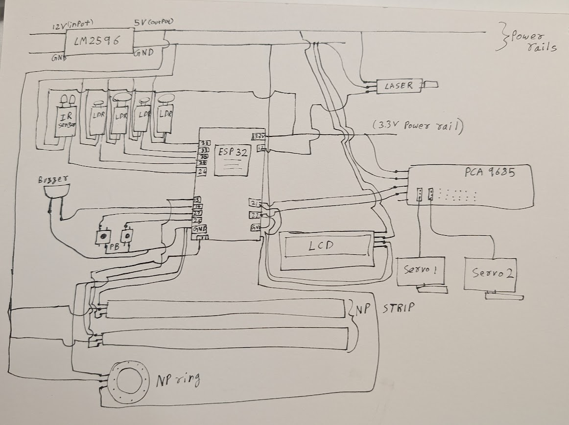

2. Components Table
Component | Quantity | Purpose | Justification
ESP32 | 1 | Main microcontroller to process inputs and control outputs | multiple GPIO pins, built-in Bluetooth capability, and ability to handle simultaneous inputs and outputs efficiently
Xbox Controller | 1 | To control laser aiming and user inputs (trigger + buttons) | Replaced joystick module due to centering issues; provides smoother, more reliable, and precise control along with better user ergonomics
Servo Motors | 4 | 2 for laser movement (X & Y), 2 for target pop-up | Servos allow controlled angular movement, making them suitable for directional aiming and repeated pop-up actions
Laser Module | 1 | To act as the shooting mechanism | Provides a visible and precise beam for accurate targeting and interaction
LDR Sensor (5mm) | 2 | To detect headshots | Smaller size enables precise targeting, increasing difficulty and skill differentiation
LDR Sensor (12mm) | 2 | To detect body shots | Larger sensing area makes detection easier, balancing gameplay difficulty
NeoPixel Ring (16 LEDs) | 1 | To display sequence, feedback, and game status | Individually addressable LEDs allow dynamic sequence visualization and real-time feedback
LED Strips | 2 | To provide additional visual feedback | Enhances immersion and makes feedback more noticeable
LCD Display (I2C) | 1 | To display instructions, prompts, and score | Ensures clear communication with the user, making the system intuitive
Buzzer | 1 | To provide auditory feedback | Gives immediate sound-based feedback for hits, misses, and game states
IR Sensor | 1 | To detect controller pickup and reset state | Enables automatic system activation and reset without additional inputs
Breadboard & Wires | Multiple | To connect all components | Allows flexible prototyping and quick modifications during development
PCA9685 Servo Driver | 1 | To control multiple servos using PWM | Reduces load on ESP32 and allows stable, precise control of multiple servos simultaneously
LM2596 Buck Converter | 1 | To regulate voltage supply to components | Ensures stable voltage output and protects components from over-voltage
DC Power Adapter | 1 | To supply power to the system | Provides consistent and sufficient power for all components
Push Buttons | 2 | Used during the recall phase for the user to replicate the sequence of targets hit | Provides a simple, reliable, and low-latency input method for sequence replication, eliminating dependence on the controller.

